





National Educational Assessment and
Examinations Agency (NEAEA)
National Exit Examination for
LL.B Programme Students of Ethiopian Law Schools
Academic Year 2015/2016
Part III: Procedural Laws and Skills Courses
31 March 2016
Time.allowed: 3 (Three) Hours
INSTRUCTIONS:
1. THIS IS A CLOSED BOOK EXAM FOR ALL MATERIALS EXCEPT
CLEAN COPIES OF THE CIVIL PROCEDURE CODE, THE
CRIMINAL PROCEDURE CODE AND THE FEDERAL COURTS
ESTABLISHMENT PROCLAMATION WHICH CANNOT BE LENT
TO NOR BORROWED FROM OTHER STUDENTS.
2. THE EXAM HAS FIVE SECTIONS. THE GRADES ALLOTTED FOR
EACH ARE INDICATED BESIDETHE TITLE OF THE SECTION.
3. WHENEVER APPROPRIATE, SUPPORT YOU ARGUMENTS WITH
PERTINENT LEGAL PROVISIONS.
4. YOU ARE EXPECTED TO ALLOCATE YOUR TIME BASED ON THE
MARKS ALLOTTED PER QUESTION.
5. WRITE YOUR ANSWERS IN THE ANSWER SHEET PROVIDED.
6. SWITCH OFF YOUR MOBILE PHONES.
Please do not turn this page until you are told to do so!
3- T'J:>

r

SECTION I: MULTIPLE CHOICE QUESTIONS (25 %)
Choose the best answer and write the letter of your choice on a separate
answer sheet appended to this exam booklet.
- Conflict of laws deals, among others, with:
- Material jurisdiction;
- Local jurisdiction;
- Internationaljurisdiction;
- Judicial jurisdiction;.-:----·
- Inter-state jurisdiction.
- Identify a statement that is correct.
- In Ethiopia, there are no rules that regulate recognition and/or
enforcement of foreign judgments.
- Ethiopia is a state party to the 1958 New York Convention on the
Recognition and Enforcement of Foreign Arbitral A wards.
- In Ethiopia, there are no rules that regulate recognition and/or
enforcement of foreign arbitral awards.
- Reciprocity is not among the conditions for enforcement of foreign
arbitral awards in Ethiopia.
- The Ethiopian Federal High Court is the court with original first instance
,
jurisdiction to entertain applications for enforcement of foreign arbitral
awards.
- Which of the following is false about conflict of laws in Ethiopia?
A .. There is a potential for intra-state conflict of laws problems to arise in
Ethiopia.
- Supreme courts of Regional States have the power to see conflict of laws
cases by delegation .
••.. C:. The F.D.R.E. Constitution contains a notion comparable to the American
~ 'full faith and credit clause. '
- The power to enact conflict of laws rules is neith%-Openly given to the
Federal Parliament nor to the Regional states. 'b ~
- The Federal High Court has original, first instance jurisdiction to see
conflict of laws cases.
- Which of the following might not be considered as an advantage of
recognizing foreign judgments/arbitral awards?
- Judicial economy.
- Discouraging non-cooperating judgment debtors..
~ Encouraging forum shopp,ing.
- Facilitation of international commerce.
- Avoiding re-litigation.

LL.B EXIT EXAM PART III : PROCEDURAL LAWS AND SKILLS COURSES MARCH 3112016

2

I

- Identify the correct statement about conflict of laws.
,A. Private international law is a branch of public international law .~
- Conflict of laws became known to the world only very recently.
- Conflict of laws deals with p..,.rivate"as well as public law matters.
- The overarching, ultimate purpose of conflicts law is ensuring fairness
-
and preventing injustice.
- Conflict of laws is international in origin and application.
- Identify the incorrect statement.
~any civil law countries regard questions of jurisdiction and enforcement
of foreign judgments/awards as falling outside the scope of conflict of
(\ laws.
B. 'Many common law countries regard . questions of jurisdiction and
enforcement of foreign judgments/awards as falling outside the scope of
conflict of laws.
- Some civil law countries like France consider the laws of nationality and
citizenship as falling within the ambit of conflict of laws.
- There is no consensus on the exact scope of conflict of laws.
- Both civil law and common law countries recognize that conflict of laws
deals, among others, with choice of the applicable law.
- Which of the following is false?
- Governing law in case of intestate succession of movable property is
usually the law of last domicile of the deceased.
- Governing law in case of succession to immovable property is usually the
law of the country where the property is loc.ated.
- As opposed to contracts, the parties are not generally free to choose the
governing law in tort ,matters.
- The traditional rule governing choice of law in tort matters is the law of
the place of wrong.
I;. In tort situations where conduct and injury occur in different states, the
governing choice of law is the law of a neutral third country.

LL.B EXIT EXAM PART III : PROCEDURAL LAWS AND SKILLS COURSES MARCH 3112016

3

- Choose an invalid statement.
A. In conflict of laws, public policy should be interpreted in a non-restrictive
-
manner.
- If application of a foreign law runs contrary to accepted norms, morality
and accepted, sense of justice of a forum state, its application may be
differed.
- Public policy provides an exception to the normal operation of choice-of-
law rules.
- A mere difference between forum law and foreign law does not imply
violation of public policy of the forum state and hence does not bar a
foreign law from appliC:f-tion.
- A court that rejected the application of a foreign law on public policy
grounds should either apply forum law or dismiss the case.
- Which of the following statements is correct regarding party autonomy?
- Parties enjoy unlimited freedom to choose the governing law in property
matters.
~....:. Parties enjoy, as a rule, freedom to choose the governing law in
commercial contracts.
- Parties enjoy absolute freedom to choose the governing law in
employment contracts.
- Parties are usually not free to choose the governing law in consumer
contracts;
- Choices of law clauses made before a dispute arises are generally more
likely to be enforced than choice of law clauses made after a dispute
¥5ar~se{ 1- / .
10. Ethiopian law of recognition/execution of foreign judgments does not
require that;
- the judgment tobe recognized/enforced has to be a final one
- the judgment to be recognized/enforced needs to have been given by a
court duly established and constituted
- the judgment debtor must necessarily participate in the foreign litigation.
- recognition/Execution of the foreign judgment in Ethiopia must not result
in violation of Ethiopian public policy
- execution of Ethiopian judgments must be allowed in the country where
the judgment to be executed was given.
- Which one of the following is least related to the rest.
- Public international law '-
- Conflict of laws
- Law of multistate problems
- Private intemationallaw
- Law of transnational problems ..

LL.B EXIT EXAM PART III: PROCEDURAL LAWS AND SKILLS COURSES MARCH 3112016

4

•• I





12. Which of the following is not relevant to pretrial lawyering?
- Collecting and analyzing documents that are relevant as evidence
- Series of discussion with the client about the various issues relevant
to the case
J:.,. Oral arguments in court
- Preparing pleadings and filing the statement of claim
- Evaluating the potential claims of the client and the possible defenses
and counter claims of the respondent.
13. One of the following is the most appropriate in the retrieval of legal
--
facts: . -----
- Identify the location of the court before the date of appointment
- Intensive research on scholarly writings rather than the laws and
Proclamations
C. Give primary attention to examining the previous decisions of the
court which is in the course of hearing the case
D. Retrieval of relevant laws, identification of all facts and gathering
IiIF Evidence
- Give prime attention to examine whether the client is telling the truth
with regard to his claims.
14. Which one of the following options is the most appropriate action for
a lawyer toward the optimum advantage of a her/his client:
A. Filing a, case to put pressure on the other party so that the latter can
come to negotiation for out of court settlement
B. Advising a client that litigation should be the last option in the
.? resolution of any case
C. Primacy to litigation rather than other options of dispute settlement if
the case seems favourable to the client, because the other party will
pay court fee and litigation cost .
- Advising the client that slhe should in all cases avoid court litigation
and all forms of dispute settlement mechanisms and focus on his business
activities even if there are laws in herlhis favour I
- Under all circumstances persuade the client towards alternative
dispute settlement mechanisms and entirely avoid litigation.
- In a case that involves injury caused to the victim due to negligence while
driving a vehicle, one of the following is not relevant in assessing damages
incurred by the victim:
(
- Medical expenses
- Lost income
~ Time of the accident
- Disability
- Pain and suffering.
rr

LL.B EXIT EXAM PART III : PROCEDURAL LAWS AND SKILLS COURSES MARCH 3112016

5

A"('-4 s s- - ':1 c,. o>b~
~ ~' .. , .
16. One of the following is not t~e regarding ~~S~~lated with trial after
the plaintiff's statement of claim:
- Serving summons
- First hearing
- The possibility of adjudication without trial where there is no issue in
dispute (in civil cases) 'f-. 'tl.- ~
- The possibility of adjudication without trial where the accused pleads
guilty in a manner acceptable by the court (in criminal cases)
~ Execution of judgment.
17. Which one of the following does not represent the tasks of a lawyer
during an appeal?
- Identifying valid issues of appeal----
- Preparing the appellate brief /'
~Under all circumstances, the need to prove fundamental error in law
CY committed in the lower court's decision.
- Persuasive oral arguments /
- Streamlining arguments in response to questions from the appellate
court.
18. According to the Civil Procedure Code, an appellate lawyer cannot
• I
introduce new evidence unless:
A. the other party agrees that it is acceptable
~he new evidence is crucial in the eyes of the party which seeks to
. submit it
C. the party that seeks to produce the new evidence was unaware of its
existence during the trial at the lower court
D. the lower court had refused to admit evidence which ought to have
been admitted
E. the party that produces the new evidence proves that its request is
made in good faith.
- The Law of Evidence does not deal with
A. collection and gathering of evidence
-B. presentation of evidence at trial
~ determination of the particular material facts which a party to litigation
must prove in order to succeed in his/her claim or defense and to show his
entitlement to relief or to obtain a conviction
- weighing of evidence
- admissibility of evidence.

LL.B EXIT EXAM PART III : PROCEDURAL LAWS AND SKILLS COURSES MARCH 3112016

6








20. ~ich one of the following is correct in respect of direct evidence?
I (b) It refers to evidence that is based on personal knowledge or observation
and that, if true, proves a fact without inference or presumption.
- It signifies evidence which is applied to the principal fact, indirectly, or
through the medium of other facts, from which the principal fact is
inferred.
- It refers to evidence that is supplementary to evidence already given in
court.
'1,...~Qs:. It refers to evidence that has any tendency to make the existence of any
:<,-, fact that is of consequence to the determination of the action more
probable or less probable than it would be without the evidence.
- It stands for a statement, other than one made by the declarant while
testifying at the trial or hearing, offered in evidence to prove the truth of
the matter asserted.
21. One of the following is not a point of difference between the law of
evidence that is applicable in civil and criminal proceedings.
- Admissibility of hearsay evidence c/
- Standard of proof A-- '
C Burden of proof . ;.
b. Cross-examination of witnesses
E. Privilege against self-incrimination.
- Exclusionary rules of evidence are primarily associated with
- common law jurisdictions ~
- civil law jurisdictions
- socialist legal systems
D. Scandinavian countries
E. hybrid legal systems.
- One of the following is a rule of evidence that does not basically operate to
protect an accused in criminal proceedings:
- exclusion of character evidence .r--
- public interest immunity
- right to remain silent
- burden of proof
- standard of proof.
- One of the following is a form of evidence produced before courts for
inspection which includes material objects, phy:sical characteristics of any
person or animal and demeanour of witnesses:
A. Documentary evidence
~eal evidence ~
- Oral evidence
- Forensic evidence,
- Electronic evidence.'

LL.B EXlT EXAM· PART III : PROCEDURAL LAWS AND SKILLS COURSES MARCH 3112016

7

25. In criminal cases, the facts in issue are ascertained by reference to:  ~ the essenti~l elements of.the o.ffence in the charge  .....--:8. the facts raised by an affirmative defense .  /  C. the staJ~l}lent of the accused during the first hearing  D . the facts agreed upon between the accused and the prosecutor  E. the facts which eye witnesses testify .  . '  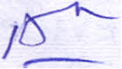  SECTION II: MATCHING (10%)  Match each item under Column "A" with its best corresponding item  under Column "B". |  | Column A
P | 1. | Transfer of suit
 | 2. | Request for admission of ~cument
If
If | 3" | Summons
If | 3" | <
, | 4. | Order of proceeding |  | S
~ | 5. | Re-examination of witness
~ | 6. | Abatement of suit | f-
 | 7. | Suit for the dissolution XYZ Share
 |  | Company
h | 8. | Interim sale
h | 9. | ~tion | L
~ | 10. Dismissal of suit
~ |  | --=-c-

Column B
- O~ by ! court r~istrar
- Change of venue
--"'--------
- Non-appearing plaintiff
- Defendant's ~ailure to appear
E. Pre-trial discovery
F. Death of a party
--=--
- Right to be heard
- Beginning of trial
\
1. . Accelerated P£fcedlJl:~
:s:===-= .
J. Summary procedUJ~
- :r~jonal ~ea~ure
- Orde~ by a court president
M. Opponent
N. Consolidation of suits
'1
- Adjou~.mo.en~: ?1c-'?'-c
- IssueJ\
Q.~n~{l.
"1
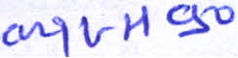
LL.B EXIT EXAM PART III: PROCEDURAL LAWS AND SKILLS COURSES MARCH 3112016
8
I
!:tf-o .-'

SECTION III: SHORT ANSWERS (15%) N~D ~
, ~-J-A"--~ fa.1j,j ',l F- 6) t:U-<-
Wt1: .---v~
Give a short answer to the following questions: - ~ '6J ::;:~
3.1. State the two basic purposes of cross-examinations.IAbout fifty wordsls POi~
'\' '
3.2. Briefly explain the legality of dnus rever!!9Z as it applies to the principle of
r-----
presumption of in no e.IAbout fifty wordsl S points
3.3. Explain the doctrine of ~"~ About fift .lword~~ts v.. ~
'(k- ~r~k ~ L Mod ~ ~v ~~
r: A ._ /) 0 t-f ~rald; '{-;p' I (lAr" p'L ~
~~ I G 'tAJ- 0 I~ //V'v-
a J i--e.lfc!: ~ -N J-L. .~)..-
SECTION IV: ESSAY TYPE QUESTIONS (20%)
4.1. Explain the legal status of rosecution disclosure under the Ethiopian
criminal procedure law. bout one hundred words 10 points
4.2. Briefly describe-the.major differences that exist between the rules of
evidence-in criminal"ahd civil cases.lAbout one hundred wordsll0 points
(:---==--- , ~
-qvA. j' '« ~
~~~
, ~~q
d^{D} ,
« ,J \ ''D -1-- r»
»>:
~' ~\~
----tJ1~
, fL

,
,
r-
Ll'
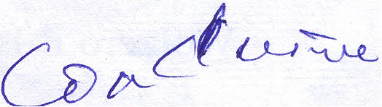

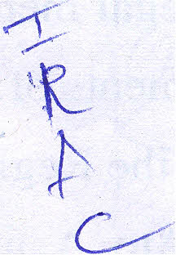


(
~
b· "

III
LI,.B EXIT EXAM PART III : PROCEDURAL LAWS AND SKILLS COURSES MARCH 31/2016 9
SECTION V: HYPOTHETICAL CA ~ OBLEM (30 %)



Ato A left the Regional State of X Jive years ago to look for a job in the Regiona
. ~,
State of ~where he currently lives and also owns a successful business
Recently, Ato A has inherited a residential villa from his late father in the
Regional State ~hiCh he later sold to Woizero B for a price of Birr 400,000
out of which Birr 300,000 was paid on the date of the signing of the contract.
W oizero B was a long time friend of Ato A's late father and she lives in a small
town at the outskirts of Regional State of X which is within the Regional SJCJ.te
, . /~
ofY.
Although the due date for delivery has passed, Woizero B did not feel
comfortable to seek the immediate delivery of the villa she bought from Ato A,
because she thought that Ato A needed some time to clear his late father's
personal effects from the villa. As the days passed, however, Ato A was
influenced by close relatives to change his mind and he cancelled the contract he
had concluded with Woizero B~ She was surprised by Ato A's action, and asked
him to receive the remaining Birr 100,000 and deliver the house to her. However,
Ato A offered to return the money he had received on the date of the contract
and he refused to vacate the villa and transfer its possession and ownership.
W oizero B is considering a legal action against Ato A to compel the latter to
transfer possession and ownership of the villa in accordance with the valid
contract of sale they have concluded in the Regional .State of Z. But she is not
\ . .
sure as to wher~she fan filfPer suit given the complexity of jurisdictional issues
~ = C ;;;p 1PF
in Federal Ethi<;>pia.· ,
She has come to you for legal advice. Write a legal memorandum advising
W oizero B as to a court that has all the requisite elements of jurisdiction to hear
and decide her claim agairist Ato A. Assume that all the Regional States o~, ~
and Z are federating units in Ethiopia and that Ato.J\--and W oizero Bare
Ethiopian nationals.
! ---------
LL.B EXIT EXAM PART III : PROCEDURAL LAWS AND SKILLS COURSES MARCH 3112016 10


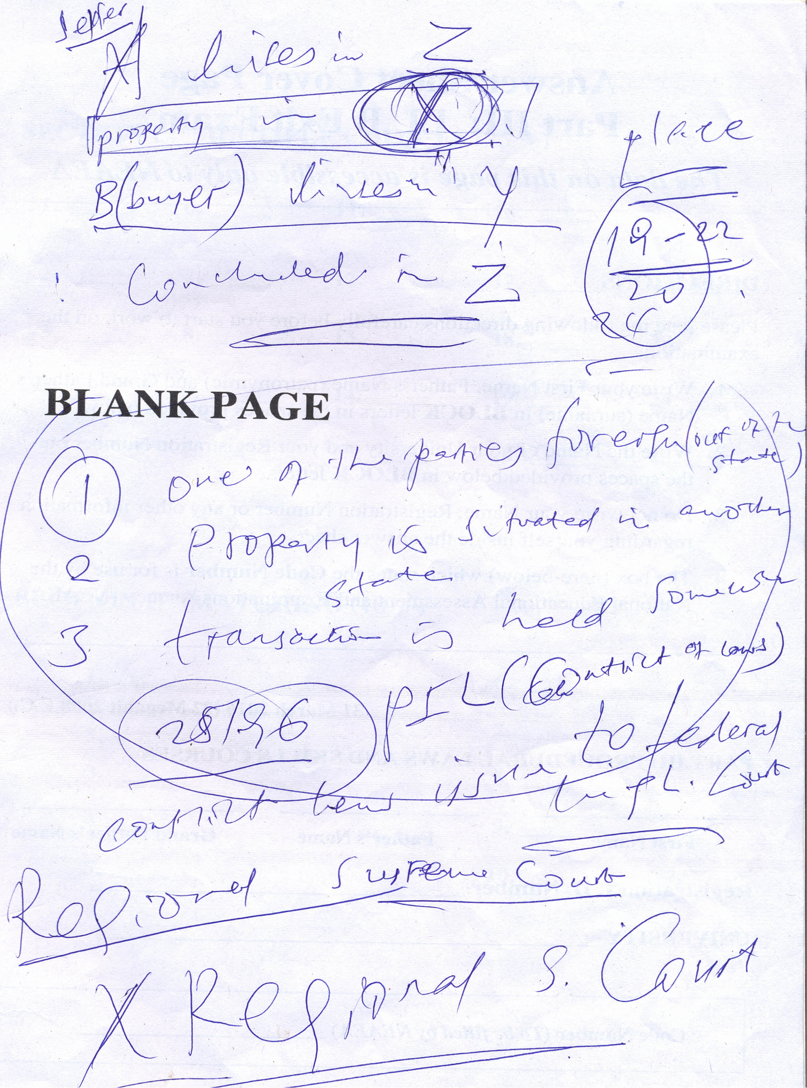
LL.B EXIT EXAM
. PART III : PROC
II
___ . _~ EDURALLAWS
. AND SKILLS
COURSES
MARCH 3112016
_
Answer Sheet Cover Page
Part III: LL.B Exit Exam
The data on this page is accessible only to NEAEA
DIRECTIONS:
Please read the following directions carefully before you start to work on the
examination.
- Write your First Name, Father's Name (patronymic) and Grand Father's
Name (surname) in BLOCK letters in the spaces provided below.
- Write the Name of your University and your Registration Number on
the spaces provided below in BLOCK letters.
- Do not write your Name, Registration Number or any other information
regarding yourself inside the answer sheet.
- The box (here-below) which states the Code Number is for use by the
National Educational Assessment and Examinations Agency (NEAEA).
31 March 2016 (22 Megabit 2008 E.C.)
PART III: PROCEDURAL LAWS AND SKILLS COURSES
First Name
Father's Name
Grand Father's Name
Registration I. D. Number _
UNIVERSITY _
Code Number (To be filled by NEAEA) _
LL.B EXIT EXAM PART III : PROCEDURAL LAWS AND SKILLS COURSES MARCH 31/2016 12

